Experiment -10
Code:
clc;
clear;
close all;
% Parameters
fs = 100000;
t = 0:1/fs:0.02;
fm = 500; % Message frequency
fc = 5000; % Carrier frequency
kf = 100; % Frequency sensitivity
% Message Signal
m = cos(2*pi*fm*t);
c = cos(2*pi*fc*t);
% FM Modulation
fm_sig = cos(2*pi*fc*t + 2*pi*kf*cumsum(m)/fs);
% Add Gaussian White Noise
noisy = awgn(fm_sig,10,'measured'); % 10 dB SNR
% Display
figure;
subplot(4,1,1)
plot(t,m)
title('Message Signal')
grid on
subplot(4,1,2)
plot(t,m)
title('Carrier Signal')
grid on
subplot(4,1,3)
plot(t,fm_sig)

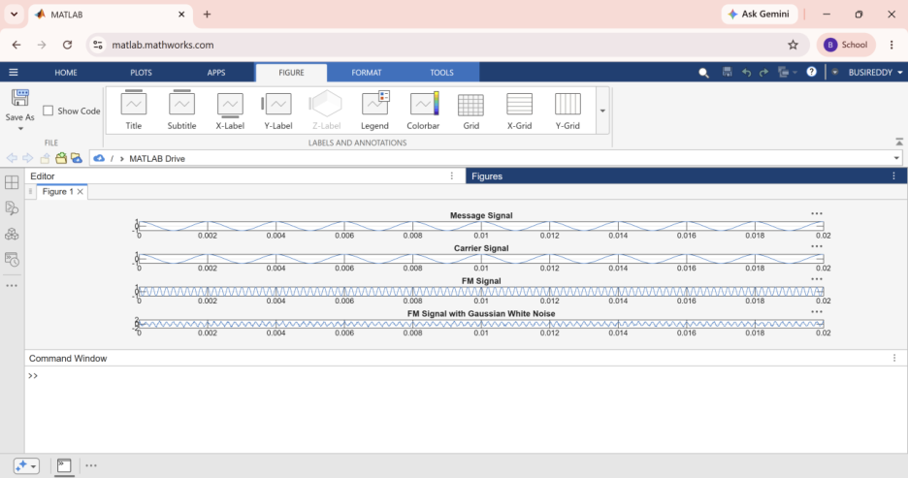

title('FM Signal')
grid on
subplot(4,1,4)
plot(t,noisy)
title('FM Signal with Gaussian White Noise')
grid on

